

CAPSTONE PROJECT REPORT
Report 2 – Project Management Plan

– Ho Chi Minh, October 2026 –
Table of Contents
I. Record of Changes 3
II. Project Management Plan 4
1. Overview 4
1.1 Scope & Estimation 4
1.2 Project Objectives 4
1.3 Project Risks 4
2. Management Approach 5
2.1 Project Process 5
2.2 Quality Management 5
2.3 Training Plan 5
3. Project Deliverables 5
4. Responsibility Assignments 5
5. Project Communications 6
6. Configuration Management 6
6.1 Document Management 6
6.2 Source Code Management 6
6.3 Tools & Infrastructures 6

I. Record of Changes
Date | A*  M, D | In charge | Change Description
28/10/2026 | A | Nguyễn Quang Hải | Added project management plan
*A - Added M - Modified D - Deleted

II. Project Management Plan

1. Overview

1.1 Scope & Estimation
# | WBS Item | Complexity | Est. Effort  (man-days)
1 | Requirements Analysis & System Design |  | 30
1.1 | SRS Documentation & Architecture Design | Medium | 12
1.2 | Database Schema & API Design (PostgreSQL, Object Storage) | Medium | 10
1.3 | UI/UX Wireframing & Design | Simple | 8
2 | Text Management & Speaker Module |  | 55
2.1 | Text Corpus Management (Import, Add, Edit, Filter) | Medium | 12
2.2 | Review Text Functionality (Sentence checking, Editing, Rejection) | Simple | 10
2.3 | Record Speech Module (In-browser audio recording, playback, re-recording) | Complex | 18
2.4 | Text Contribution & Validation Flow | Simple | 15
3 | Recording Review & Quality Control Module |  | 60
3.1 | Task Assignment & Review Queue for Reviewers | Medium | 12
3.2 | Audio Player & Quality Assessment Interface | Complex | 18
3.3 | Approve / Reject Recordings with Specific Reason Recording | Medium | 15
3.4 | Review Progress Tracking & History Management | Medium | 15
4 | Task, Target & Dashboard Management |  | 55
4.1 | Task Manager Module (Create/Assign tasks, set targets & deadlines, reassign) | Medium | 18
4.2 | Admin User & Role Management (Speaker, Reviewer, Task Manager, Admin) | Simple | 10
4.3 | Statistics Dashboard & Analytics (Audio duration, approval rate, reasons) | Complex | 17
5 | Integration, Testing & Deployment |  | 40
5.1 | System Integration & Audio Quality QC Tools Integration | Complex | 15
5.2 | System Testing & Bug Fixing | Medium | 15
5.3 | Server Deployment & User Acceptance Testing (UAT) | Medium | 10
Total Estimated Effort (man-days) |  |  | 240

1.2 Project Objectives
[Provide the overall project objective description and then the specific target metrics of your project in term of quality, time, and cost (allocated effort distribution for project activities: requirement, design, coding, testing, project management, etc). For example
Quality
# | Testing Stage | Test Coverage | No. of Defects | % of Defect | Notes
1 | Reviewing
2 | Unit Test
3 | Integration Test
4 | System Test
5 | Acceptance Test

Milestone Timeliness (%):
Allocated Effort (man-days):
]

1.3 Project Risks
# | Risk Description | Impact | Possibility | Response Plans
1 | Inconsistent audio quality or background noise from user devices during recording | High | High | Implement browser-based audio pre-checks, noise filters, and detailed Recording Guidelines for Speakers.
2 | Audio storage and bandwidth bottlenecks due to large speech dataset uploads | High | Medium | Use Object Storage (AWS S3/MinIO) with audio compression (FLAC/WAV format conversion)
3 | Disagreements among Reviewers on Vietnamese-English code-switching pronunciation/labels | Medium | High | Define clear review criteria, standard phonetic rules, and add random multi-reviewer cross-checks.
4 | Delay in team members' task completion due to academic workload | High | Medium | Weekly progress tracking via Zalo; reallocate tasks early if delay > 2 days.
5 | Performance lag during concurrent recording/reviewing activities | Medium | Medium | Optimize Backend APIs, implement database indexing, and use WebSocket for audio streaming.

2. Management Approach
The team applies the Agile/Scrum software development process model. The development timeline (Sep 2026 - Mar 2027) is divided into 12 Sprints (2 weeks per Sprint):
-Sprint Planning: Held at the beginning of each sprint to select backlog items.
-Daily Standup: Quick 15-minute syncs to identify blockers.
-Sprint Review & Retrospective: End-of-sprint demonstration to Supervisor and internal evaluation.

2.1 Project Process
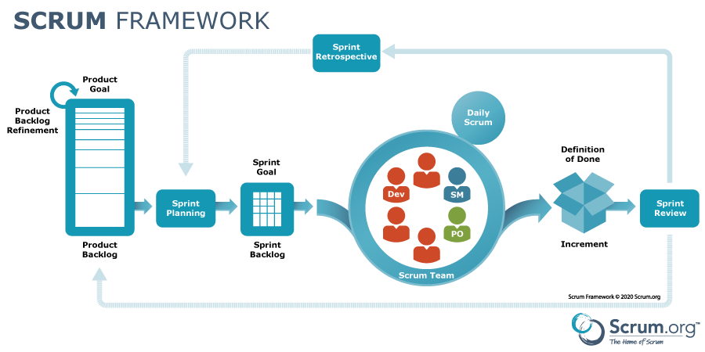
Figure 01 - Scrum Framework
https://www.scrum.org/resources/scrum-framework-poster

2.2 Quality Management
To achieve quality objectives, the team enforces:
-Defect Prevention: Standardize code style guidelines, enforce GitHub Pull Request reviews (at least 1 approval required before merge).
-Reviewing: Requirement reviews, technical design reviews, and code walkthroughs.
-Unit Testing: Mandatory unit tests for backend APIs and audio processing utilities.
-Integration Testing: Automated API testing using Postman/Jest.
-System & QC Testing: End-to-end testing of user flows and real speech quality validation.

2.3 Training Plan

Training Area | Participants | When, Duration | Waiver Criteria
ReactJS | Front-end devs |  | Mandatory
PostgreSQL | Back-end devs |  | Mandatory
Git, Github | All Members |  | Mandatory

3. Project Deliverables
# | Deliverable | Due Date | Notes
1 | Project Charter & Management Plan (Report 1 & 2) | dd/MM/yyyy
2 | Software Requirement Specification (SRS) & Architecture Doc
3 | Module 1: Text Management & Speaker Recording System
4 | Module 2: Recording Review & Quality Control System
5 | Module 3: Task Manager & Admin Statistics Dashboard
6 | Complete CodeSwitchLabel System & Tested Speech Dataset
7 | Final Capstone Project Report & Presentation

4. Responsibility Assignments
D~Do; R~Review; S~Support; I~Informed; <blank>- Omitted
Responsibility | LucNM SE141086 | HaiNQ SE171707 | KhanhHLNSE161401 | LanDDT SE171568
Project Planning & Tracking
Prepare Project Introduction Document
Prepare SRS Document (Overview Part)
Prepare SRS Document (User Requirements)
Prepare SRS – Functional Requirements
Prepare SRS – Non-Functional Requirements
Prepare SRS – Other Requirements

5. Project Communications
Communication Item | Who/ Target | Purpose | When, Frequency | Type, Tool, Method(s)
Daily Meeting | Team Members | • Review project progress  • Discuss and solve problems | Always | Google Meet, Zalo, Face to Face
Meeting supervisors | Supervisors and Team Members | • Review project progress  • Review project document, core flows  • Technical support  • Give advice and direction | 1 time per week | Google Meet, Zalo, Face to Face

6. Configuration Management

6.1 Document Management
We rely on Google Drive for all project documents because it provides real-time sync and co-editing. Team members can work in the same file simultaneously, add comments, and resolve suggestions without version chaos. To keep things tidy, we use a simple folder structure accordingly. Major document revisions are captured via Drive version history with short change notes, and finalized PDFs are exported to a Releases folder for sign-off.

6.2 Source Code Management
We host source code on GitHub, using Git for distributed version control. The team collaborates through feature branches and pulls requests to ensure code is reviewed before merging. Our default model is trunk-based with short-lived branches; branch names follow a convention (e.g., feat/, fix/, chore/), and PRs reference related issues. Code reviews check correctness, security, and style; status checks/CI must pass before merge. Git history makes it easy to trace who changed what and when, quickly diagnose regressions, and roll back if needed.

6.3 Tools & Infrastructures
Category | Tools / Infrastructure
Technology | ReactJS (FrontEnd), Java/SpringBoot (BackEnd)
Database | PostgreSQL, MinIO
IDEs/Editors | Visual Studio Code
Diagramming | DrawIO
Documentation | Ms Office, Google Docs/Sheets, Canva
Version Control | GitHub (Source Codes), Google Drive (Documents)
Deployment server | Azure
Project management

